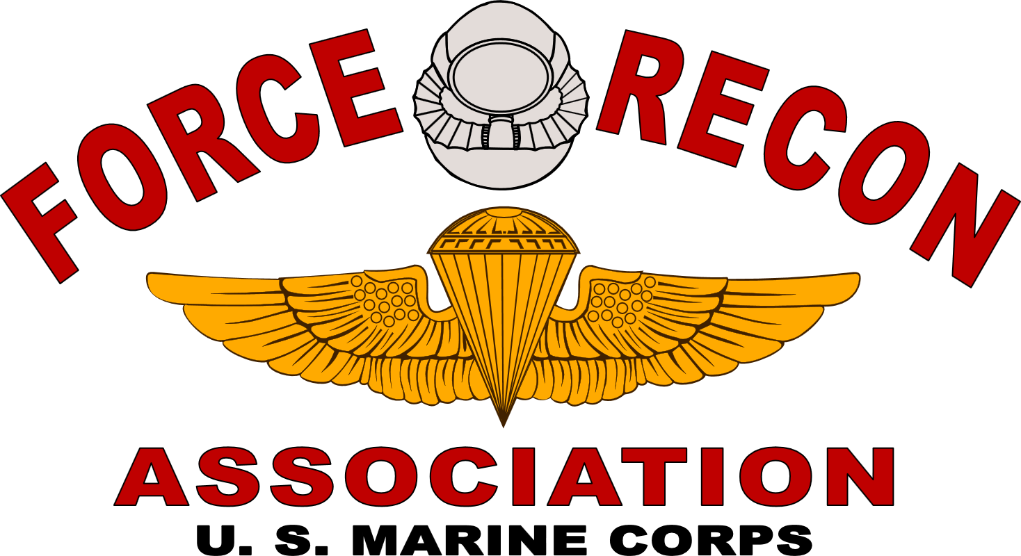

“Link forever those who served together”

SCHOLARSHIP APPLICATION
For the Academic Year

Please Print Name Clearly

Revised 10/01/2020
FRA SCHOLARSHIP APPLICATION
NOTE: Scholarship awards may be used for scholastic, vocational/technical education. The total number of scholarship awards that any individual may receive is four (4).

General Requirements: Please read carefully – applications not meeting the full requirements below will be disqualified!

1. Applicant must be a Member (in good standing) of the Force Recon Association (FRA) or be a direct family member of the Sponsor.
2. Sponsor must be a Member (in good standing) of the Force Recon Association (FRA).
3. Both “Applicant” and “Sponsor/Guardian” MUST sign the” Attestations” block on page 5 or the application will be disqualified.
4. Parts III, IV, and V must be completed per the instructions. The applicant may choose to type/write these sections on separate pages. Also, you may submit a resume as supplemental information; however, the resume cannot be accepted as substitute information for Parts III through V.
5. Official and signed Transcripts are required FOR ALL INSTITUTIONS ATTENDED: NO EXCEPTIONS!! If applying directly from high school, please submit high school transcripts.
6. A copy of the institution’s acceptance/enrollment letter to the applicant must be provided. If there is any future change in institutions, a letter of acceptance will again be required as part of the application.
7. A minimum of three (3) letters of recommendation with original signatures of the authors must be submitted. One letter must be submitted by an instructor/professor and one letter may be submitted by the sponsor. Again, all recommendations must be signed by the author.
8. Please provide single sided copies of all documents and remove all staples since your application will have to be copied.
9. Selection for Force Recon Association Scholarships will be based upon a combination of academic achievement, letters of recommendation, demonstrated character, and the applicant’s personal statement.
10. The Force Recon Association’s elected Board of Directors makes the final Scholarship Award selections based upon the recommendations of the Force Recon Association Scholarship Committee.
11. Scholarship recipients will be notified via mail in the Fall of the award year.
12. Fully completed Application packages must be received by July 1st of the calendar year. Incomplete or late packages are automatically disqualified.
DO NOT REQUEST signature receipts when mailing documents.
13. Previous scholarship recipients are eligible to reapply as long as all eligibility requirements and all application materials are resubmitted including all transcripts.
14. For consideration completed applications should be mailed to:
FORCE RECON ASSOCIATION SCHOLARSHIP COMMITTEE
2928 Cambridgeshire Drive, Carrollton, TX 75007
FORCE RECON ASSOCIATION
United States Marine Corps
“Link forever those who served together”

SCHOLARSHIP APPLICATION

Part I -Applicant Information
Please Type or Print clearly
Name:

Social Security Number:

Mailing Address:
City: State: Zip:

Permanent Address:

(If different than above)
City: State: Zip:

Home Phone: School Phone:

(Area Code) Number (Area Code) Number

Part II - Sponsor Information
Relationship To Sponsor:

Sponsor Name: FRA #:
Social Security Number:

Mailing Address:
City: State: Zip:

Home Phone: Business Phone:

(Area Code) Number (Area Code) Number

If Deceased, Place of Death:

Part III - Extracurricular Activities and Awards (Include School, Community, Military, and Others, as appropriate)

Part IV -Brief History of Work Experience (Include Job Titles and Dates)

Part V -Personal Statement. To include, as a minimum:
- Why do you desire this Scholarship?
- What is your proposed course of Study?
- Progress in your current course of study, if you have previously received a FRA Scholarship.
- Your long-range career goals.
(You may attach additional pages, as necessary, or you may type your statement and attach it to the application)

Part VI – Educational Information
NAMES AND ADDRESSES OF SCHOOLS ATTENDED, TO INCLUDE HIGH SCHOOL AND COLLEGES OR UNIVERSITIES, AS APPROPRIATE. GIVE DATES ATTENDED AND GRADUATION DATES. (Attach additional sheets as necessary)

Attestations

We believe that all the information and statements made in this application are true and correct to the best of our knowledge. Should they be found otherwise, we understand this would void any consideration for Force Recon Association scholarship awards. Additionally, we authorize the Force Recon Association to publish our names in any communications of the Association and specifically in the SITREP newsletter.

Applicant Signature Sponsor/Guardian Signature
(If Applicable)

Date Date

